DAD-220 Intro to Struct Database Env-T1393

Professor Agarwal

Matt Bramer

1 September 2020

1-4 Practice Query Language in Codio

1. **Begin working with command line in MySQL** by typing the following command:
   1. **Mysql**
      1. Press Enter

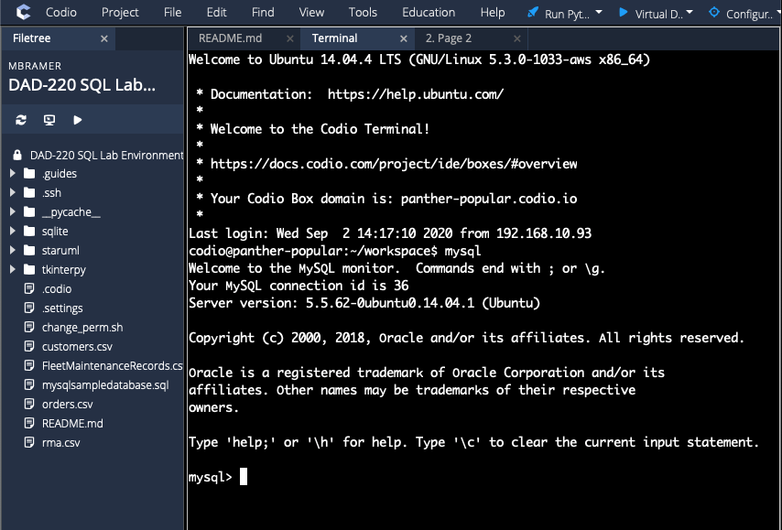

* 1. Create database (last name here);

* 1. Show databases;

* 1. Use (last name here);

1. **Create a table called tb2 and list out the tables in your database** with one field by typing the following commands after the prompt mysql>
   1. Create table tb2 (user_id VARCHAR( 50 ));
      1. Press **Enter**.

* 1. Show tables;
     1. Press **Enter.**

* 1. Describe tb2;
     1. Press **Enter.**

1. Now, **add a second field** by entering the following commands after mysql>
   1. Alter table tb2 add newfield VARCHAR(25);
      1. Press **Enter.**

* 1. Describe tb2;
     1. Press **Enter.**

